 

ProjectTitle:LeaseManagement

CollegeName:SREE SAKTHI ENGINEERING COLLEGE:7136

DepartmentofComputerScience andEngineering

## TeamLeader:

Name:Gokul A R RegNo:713621104014

## TeamMembers:

Name:Prabakaran P RegNo:713621104314

Name:Lingeshwar M S RegNo:713621104307

RegisteredEmailId:prabhaprabha9453@gmail.com

 

# ProjectName:LeaseManagement

### Projectoverview:

This initiative focuses on developing a Lease Management System in collaboration with Salesforce.com to create an application tailored for property management. The LMS application encompasses all essential features required to oversee various operations within the real estate industry, adhering to established best practices. Offered as a Software as a Service (SaaS), it is accessible online from any device. The technological framework is backed by Salesforce.com (www.salesforce.com), ensuring secure data storage and the implementation of necessary security measures. The objective of this study was to design and implement a cloud-based Lease Management System that provides detailed and summarized insights into critical areas, aiding LMS administrators in their planning and decision-making efforts. The system is available anytime and anywhere, as data is stored remotely and accessible via the Internet. This project emphasizes user-friendliness, usability, performance, and security, demonstrating its robustness. Consequently, other property owners may be inclined to adopt this system for enhanced information management, improved decision-making, and the maintenance of strong client relationships, as the LMS facilitates the management of real estate operations.

### Objective:

The main objective of a leave management system is to help businessesmanageemployeeabsencesinafairandaccurateway.Thiscanbeachievedby:

**Business Target:**

Asset leasing is a widely adopted practice among businesses of all types and sizes. This method presents numerous benefits, including greater purchasing power, lower maintenance costs (assuming the lessee does not bear maintenance responsibilities), and more effective cash flow management.

 

**Particular goal:**

Leasing assets has emerged as a common tactic for businesses in diverse sectors and of varying sizes. This method presents several benefits, including greater purchasing power, decreased maintenance costs (if the lessee is not liable for maintenance), and enhanced cash flow management.

**Enhancing the efficiency of the leave application process.**

#### A leave management system acts as a link between employees and employers, improving the effectiveness of the leave application and approval process.

#### Facilitating clarity and management.

It is essential for employees to have an easy-to-follow system for applying for leave, accessing their leave information, and tracking the status of their leave applications.

**Streamlining processes by removing paper-based tasks**

#### The implementation of leave management systems enhances the efficiency of leave request handling, significantly lowering the necessity for manual processing and related paperwork.

#### Fulfilling legal requirements.

#### Meeting state-imposed legal obligations is an essential element of an effective leave management system.

 

**SalesforceKeyFeaturesandConceptsUtilized**

**Organization:**

Establishing a detailed sales plan and assigning roles to team members.

**Sales Tactics:**

Creating and executing strategies that are clear and actionable.

**Customer Engagement:**

Nurturing valuable relationships with key clients.

**Sales Data Analysis:**

Reviewing historical campaign data to develop improved and more efficient campaigns.

**Training:**

Guiding sales representatives to boost their performance and realize their maximum potential.

**Forecasting:**

Preparing for future needs to ensure appropriate inventory and staffing levels, along with compensation planning.

 

# Detailedstepstosolutiondesign

### Step1:CreatingDeveloperAccountandActivation

To create a developer organization within Salesforce, start by activating your account.

Click on the "Verify Account" link, then set a password and provide an answer to a security question.

After clicking "Change Password," you will be redirected to the Salesforce setup page.

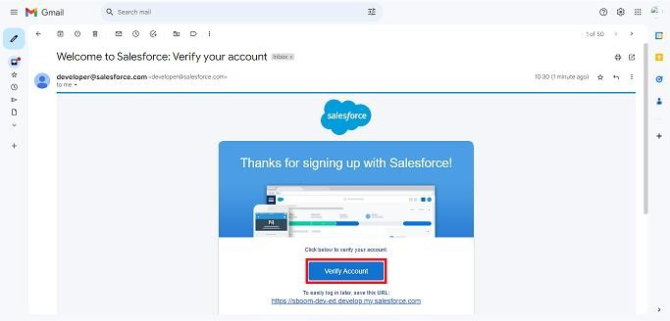

 

### Step2:Createofobjects

CreatePropertyObject,tenantobject,leaseobjectandpaymentobject.

Fromthesetuppage>>ClickonObjectManager>>ClickonCreate>>ClickonCustomObject

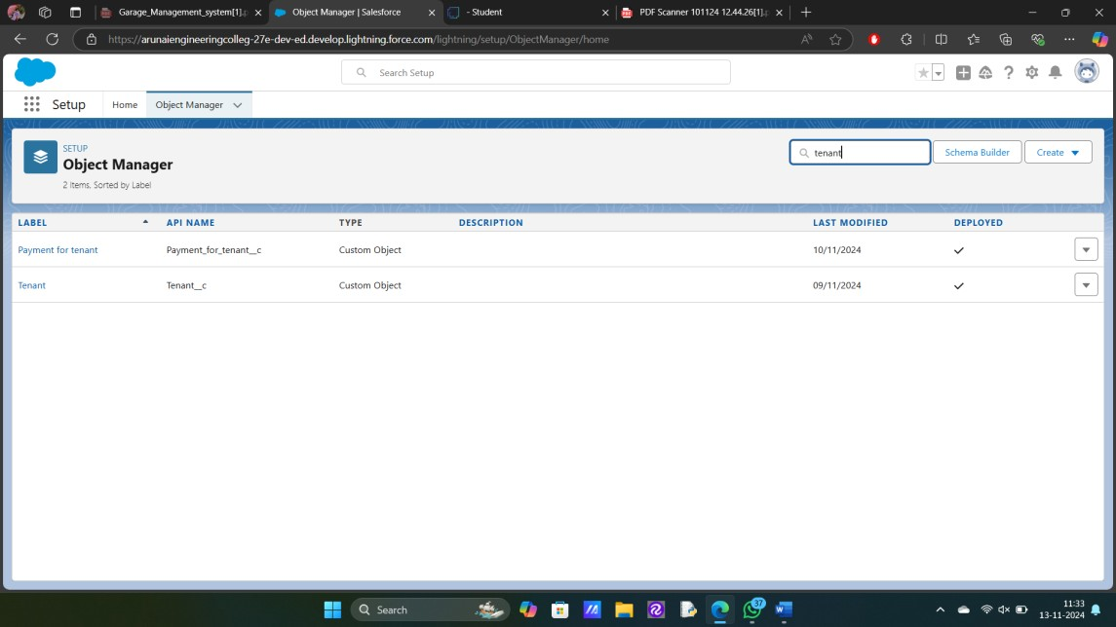

Enterthelabelnamefortheappropriateobject.ThenenterthePlurallabelname.

EnterRecordNameLabelandFormatRecordNameandDataType.

### Step3:CreatingaCustomTab

Atabislikeauserinterfacethatisusedtobuildrecordsforobjectsandtoviewtherecordsintheobjects.

 

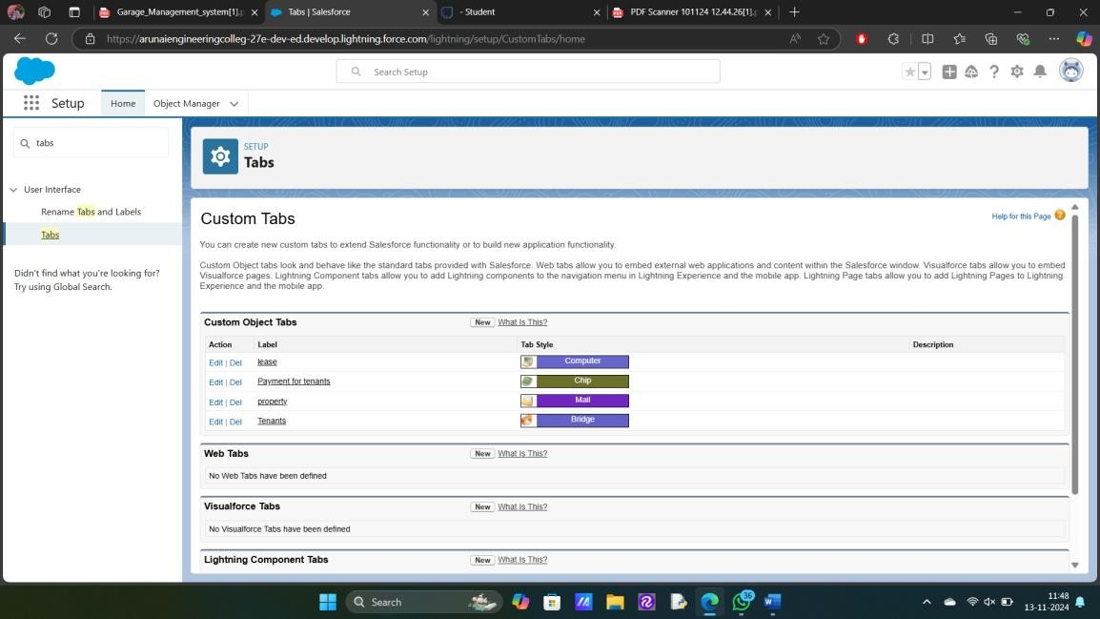

### Step4:CreateaLightningApp

Anappisacollectionofitemsthatworktogethertoserveaparticularfunction.

### TocreateaTab:(Property)

* Gotosetuppage.Searchtabsonquickfindbarclicknewundercustomtab.
* Thefirststepistoselectobjectpropertyandtabstyle.
* MakesurethattheAppendtabtousers'existingpersonalcustomizationsischecked.Clicksave

 

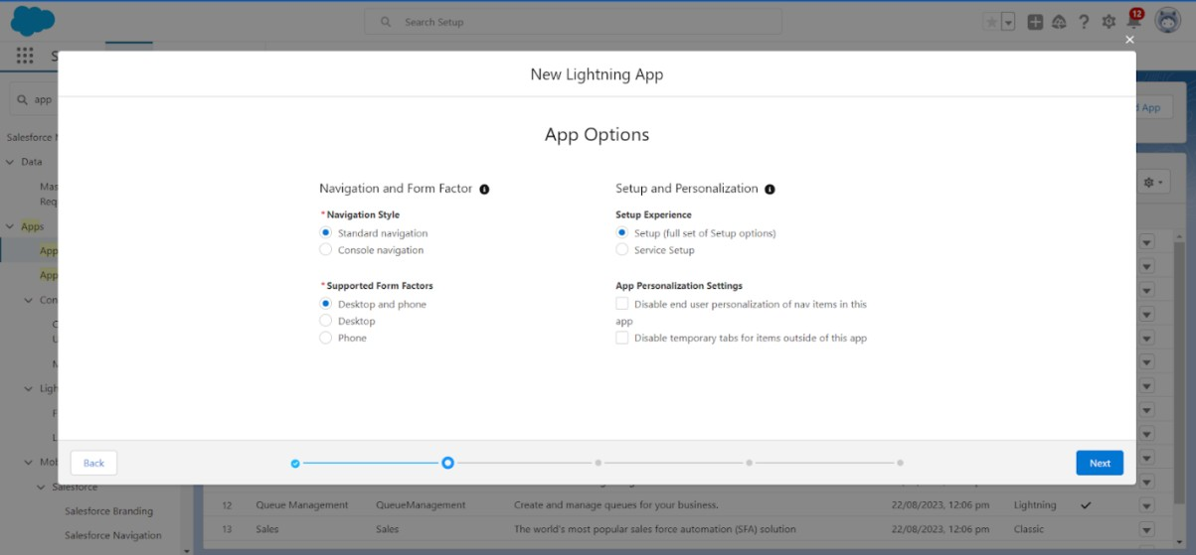

Createalightningappwithan AppNameof“LeaseManagement”

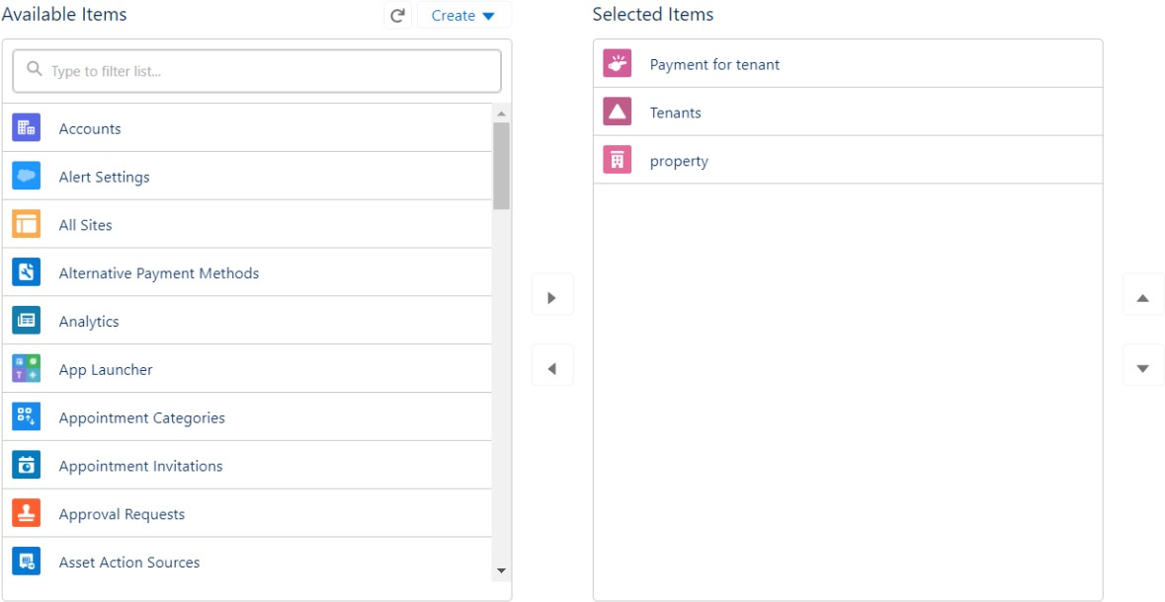

### Step5:FieldCreation

Creationoffieldsforthepropertyobject,Tenantobject,Leaseobject,Paymentfortenantobject,Lookupobject.

 

GotosetupthenclickonObjectManagertotypeobjectname(Tenant)insearchbarand clickontheobject.

* FieldLabel:Email
* FieldName:getsautogenerated
* Clickonrequiredcheckbox
* ClickonNext>>Next>>Saveandnew.
* FieldLabel:startdate
* FieldName:getsautogenerated
* ClickonNext>>Next>>Saveandnew.

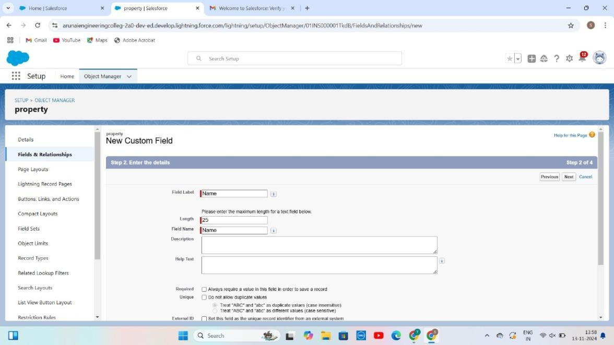

 

### Step6:Validationrules

TocreateavalidationruletoanLeaseObject.

GotothesetuppageclickonobjectmanagerfromdropdownclickeditforLeaseobject**.**

Clickonthevalidationrule.clicknewRule name=lease_end_date

* + InserttheErrorConditionFormulaas:End_date c>start_date c

EntertheErrorMessageas“YourEnddatemustbegreaterthanstartdate”,select the Error location as Field and select the field as “start date”, and clickSave.

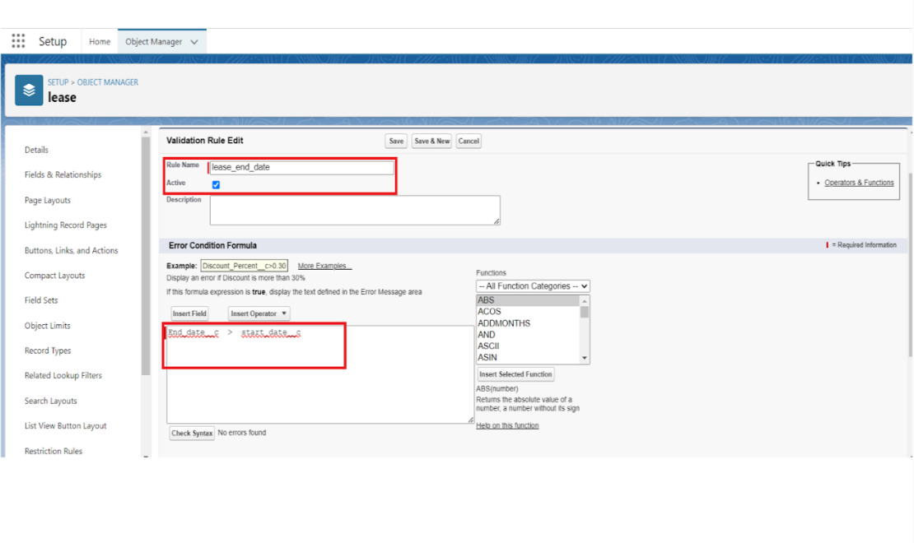

 

**Step7:Emailtemplates**

### CreateEmailTemplateForTenantLeaving

* + Gotosetupinquickfindboxenter emailtemplate,clickonclassicEmailtemplate.
  + Thenclickonnewemailtemplatechoosetext
  + Emailtemplatename:tenantleaving
  + Templateuniquename:Autopopulated
  + Subject:requestforapprovetheleave
  + Emailbody:

Dear{!Tenant c.CreatedBy},Pleaseapprovemyleave.

* + Save.

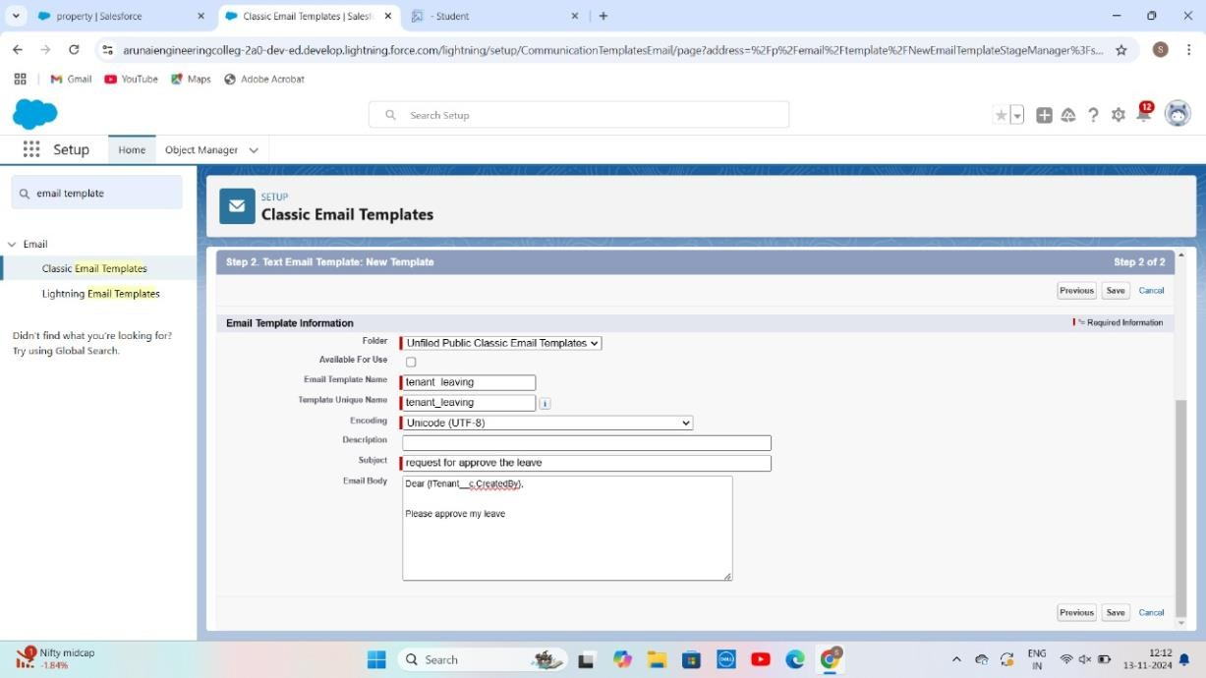

 

### CreateEmailTemplateForLeaveApproved

* + Gotosetupinquickfindboxenter emailtemplate>>clickonclassicEmailTemplate.
  + Clickon>>NewEmailTemplate===>Choosetext
  + EmailTemplateName=Leaveapproved
  + TemplateUniqueName:Autopopulated
  + Subject=Leaveapproved
  + Email body:
  + dear{!Tenant c.Name},

I hope this message finds you well. I am writing to inform you that Ihavereceivedyouremailconfirmingtheapprovalofmyleaverequest.I would like to express my gratitude for considering and approving mytimeoff.

Yourleaveisapproved.Youcanleavenow.

* + Save

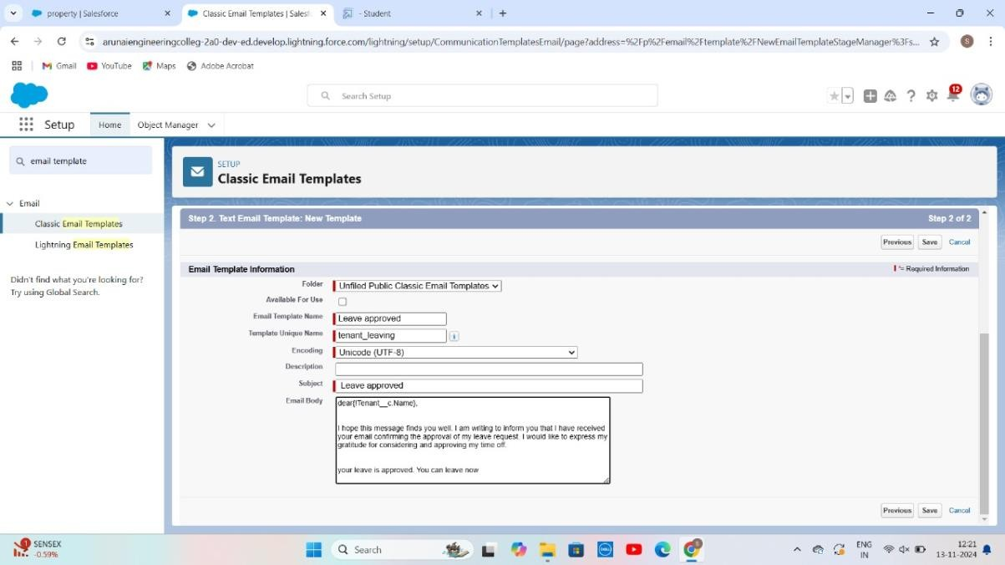

 

### CreateEmailTemplateForrejectionforleave

* + Gotosetupinquickfindboxenter emailtemplate>>clickonclassicEmailTemplate.
  + Clickon>>NewEmailTemplate===>Choosetext
  + EmailTemplateName=Leaverejected
  + Subject:”Leaverejected”
  + Email body:
  + Dear{!Tenant c.Name},
  + Ihopethisemailfindsyouwell.Yourcontracthasnotended.Sowecan'tapproveyourleave
  + yourleavehasrejected
  + Saved

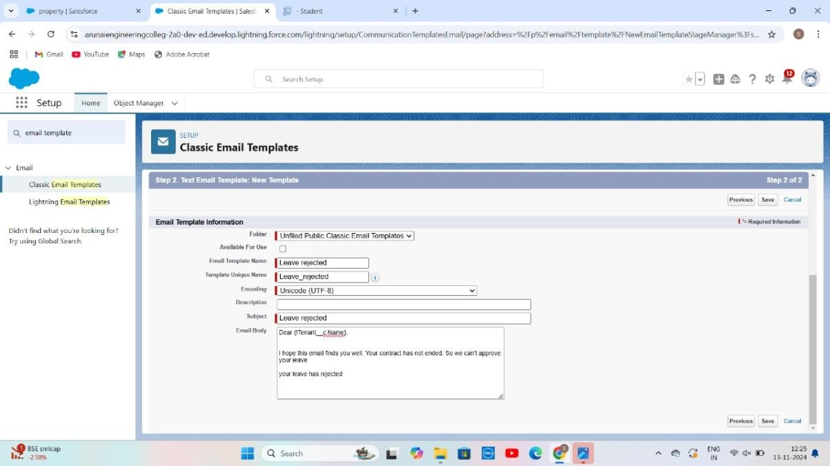

 

## Step8:ApprovalProcess

### WhatIsApprovalProcessInSalesforce?

TheApprovalProcessisanautomatedprocessthatanorgusestoapproverecords in Salesforce. For example, When In the organization, someone is notable todecide aparticularthingthenhecanasksomeone elsefor

approval. So, for such frequent cases or situations, one can define the approvalprocess.So,Userscantakebenefitofsuchanapprovalprocesswhenever

needed.

Thereare4actions,

1. InitialSubmissionActions
2. FinalApprovalActions
3. FinalRejectionActions
4. RecallActions.

Anapprovalprocessconsistsoffinalizingthebasicpropertiesoftheapprovalprocess(asshowninthebelowimage),approvalsteps,andactionsto be

executed.

### CreateApprovalProcessForcheckforvacant.

* + Gotosetup>>ApprovalProcessesinquickfindbar>>clickonit.
  + ManageApprovalProcessFor>>“Tenant”fromthedropdown.
  + Clickon“CreateNewApprovalProcess”>>Usestandardsetupwizard
  + ProcessName“checkforvacant”>>ClickNext.
  + Field“Tenant:status”>>Operator:Notequals,Value>>Clickonthelookupfiltericonandselect“Leaving”.
  + 6.Clickinsertfield,thenclickNext.

 

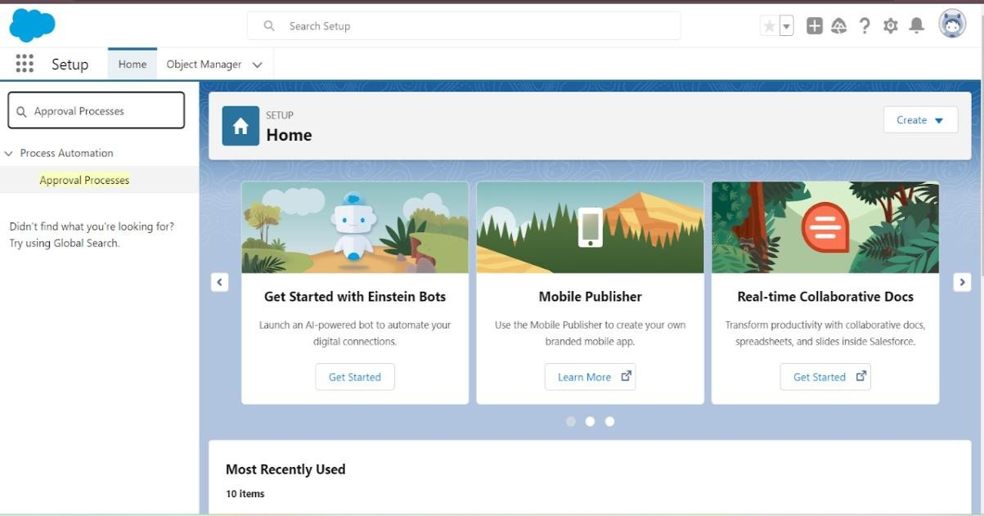

* NextAutomatedApproverdeterminedby“None”fromthedropdown.
* Selectthe“AdministratorsONLYcaneditrecordsduringtheapprovalprocess”.ThenNext.

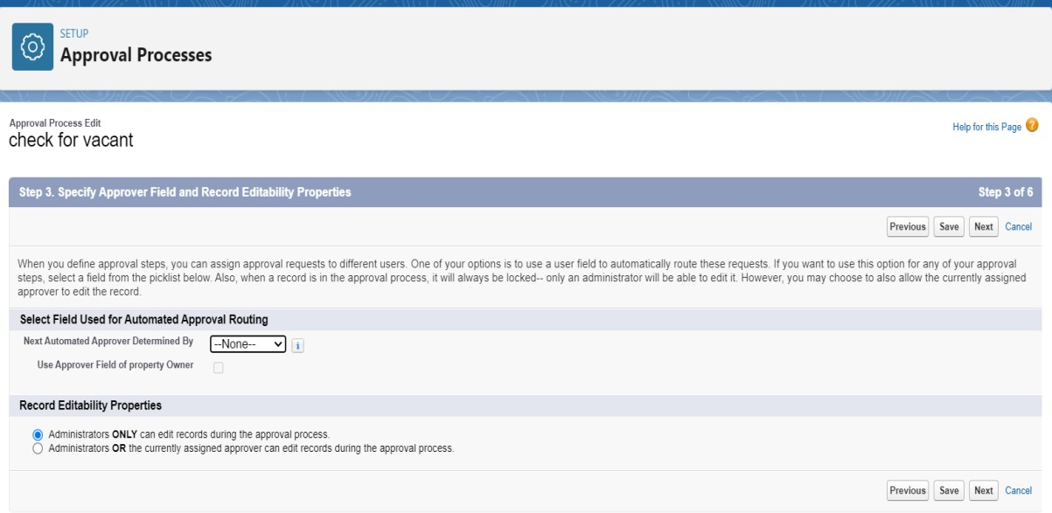

 

* Clickonnextleavetheemailtemplateclickonnext
* SubmittertypeSearch>>Owner,AllowedSubmitters>>PropertyOwner.ThenNext.
* ThenclickonSave.

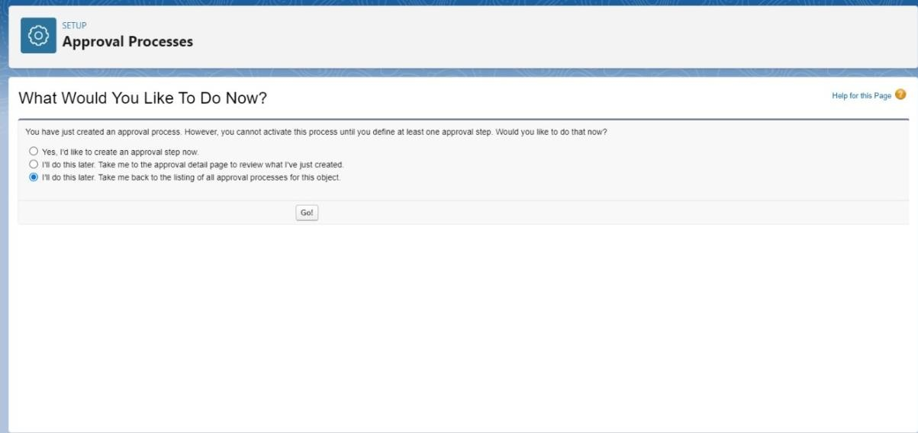

* Clickon“i’lldothislater.Takemebacktothelistingofallapprovalprocessforthisobject”
* Clickgo.

### InitialSubmissionAction:

* + Under initial submissionactionclickonaddnewandthenselectemailalert.
  + Description:“pleaseapprovemyleave”.
  + Uniquename:autopopulated.
  + Emailtemplate:tenantleaving.
  + Recipienttype:Emailfield.

 

## Step8:Flows

InSalesforce,aflowisatoolthatautomatescomplexbusinessprocesses. Simply put, it collects data and then does something withthat data. Flow Builder is the declarative interface used to buildindividualflows.

**CreateFlowformonthlypayment**

1. Gotosetupthen typeFlowinquickfindboxClickontheFlowandSelecttheNewFlow.
2. SelecttherecordTriggeredflow.Clickoncreate.

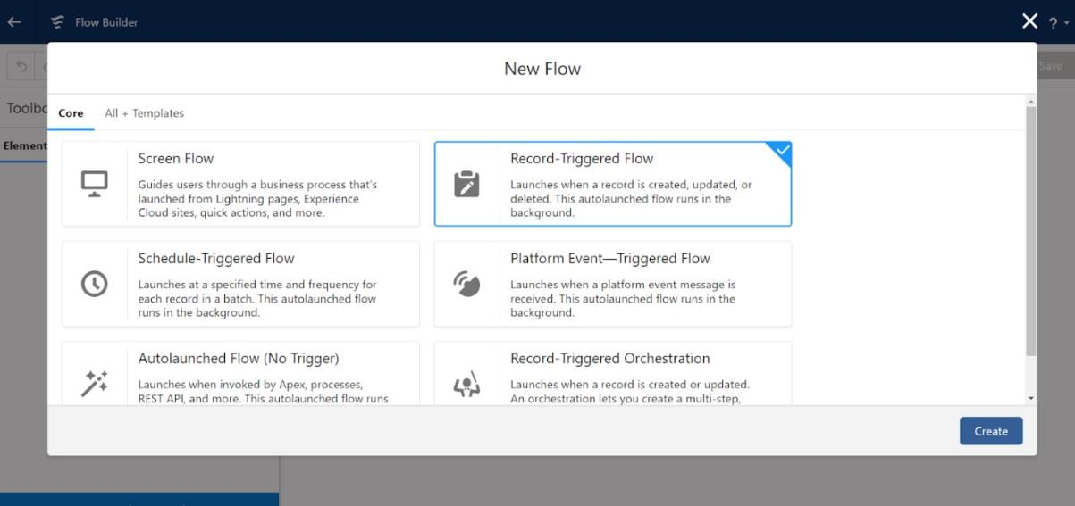

Clickon:Everytimearecordisupdatedandmeetsthe

conditionrequirementsClickon:Actionsandrelatedrecordsisdone

 

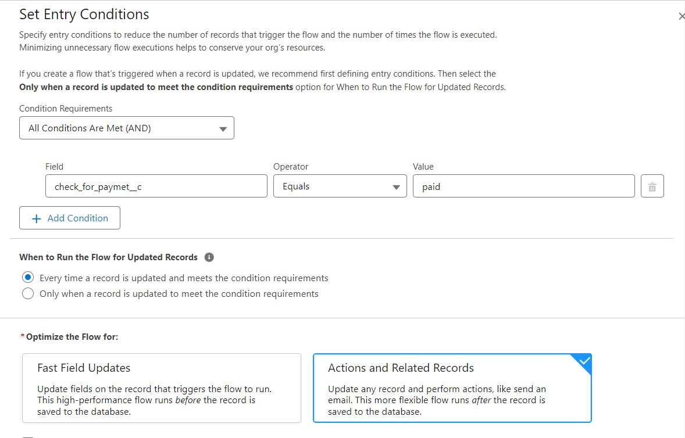

## Testandvalidation:

Testingandvalidationinleasemanagementcaninvolveavarietyofactivities,including:

**Leasevalidationservices:**

Helppropertymanagementcompaniesensurethatleaseagreementsarelegalandenforceable.Theseservicescanhelpidentifyissuesandverifythetermsandconditionsofalease.

### Testplanningandexecution:

Thisinvolvesexecutingandmonitoringvalidationtests

according to a test plan and design. It also includes verifying andvalidatingthetestresults,andrecordingandreportinganyissuesordefects.

 

### Testobjectivesandcriteria:

Theseshouldbedefinedclearlyandexplicitlybeforestartingtesting and validation. They should align with the project's goals,scope, specifications, and the needs and expectations of thestakeholdersandusers.

### Validationtesting:

Thisisusedtoverify thatthefinalproductmeetsthe

expectationsandrequirementsofthecustomersandstakeholders.Itusually happens after the product is fully developed and focuses onconfirmingthatitworksasintendedinreal-worldscenarios.

# Conclusion:

# Lease financing is a strategic option for individuals who encounter challenges in securing funds through debt financing. It enables asset holders to lease their properties to businesses, fostering a positive relationship between the lessor and lessee. Our CRM-enhanced lease management system improves this process by helping users discover ideal locations for both residential and commercial applications. This initiative proves beneficial for residential clients as well as business owners.